CST-361 Design Patterns in Java
Samantha Krall
Activity 2: GoF Design Patterns
December 2018
Write up:
Builder: The builder pattern is used to create complex objects with the constituent parts that must be created in the same order or using a specific algorithm. An external class controls the construction algorithm. It is a creational pattern, which provides ways to instantiate single objects or groups of related objects.
Chain of Responsibility: The chain of responsibility pattern is used to process varied requests, each of which may be dealt with by a different handler. It is a behavioral pattern, which defines manners of communication between classes and objects.
Façade: The façade pattern is used to define a simplified interface to a more complex subsystem. It is a structural pattern, which provides a manner to define relationships between classes or objects.
Deliverables:
Builder:
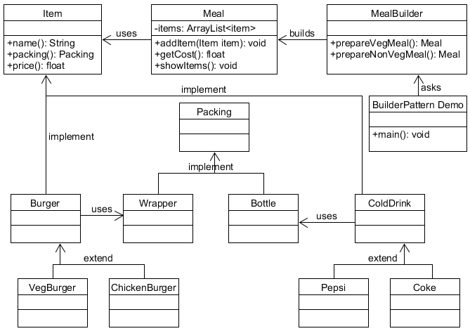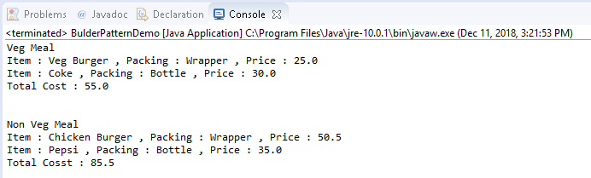
Chain of Responsibility:
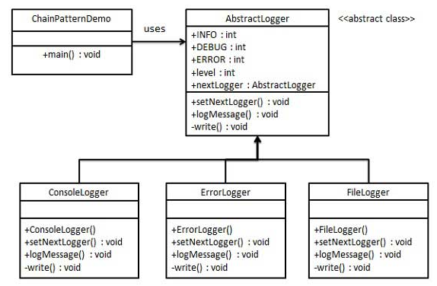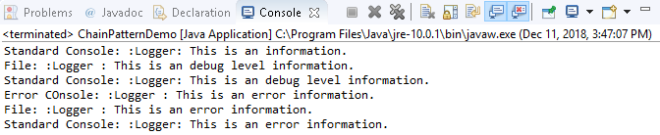
Façade:
